Sets Functions

# union()

Return a set containing the union of sets

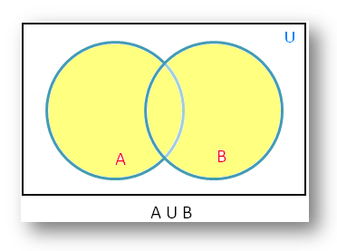

## Code:

a = {1,2,3,4,5}

b = {4,5,6,7,8}

x = a.union(b)

print(x)

## Output:

{1, 2, 3, 4, 5, 6, 7, 8}

# intersection()

Returns a set, that is the intersection of two other sets

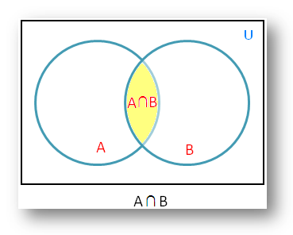

## Code:

a = {1,2,3,4,5}

b = {4,5,6,7,8}

x = a.intersection(b)

print(x)

## Output:

{4,5}

# difference()

Returns a set containing the difference between two or more sets

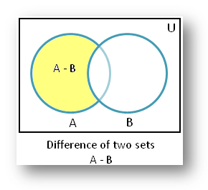

## Code:

a = {1,2,3,4,5}

b = {4,5,6,7,8}

x = a.difference(b)

print(x)

## Output:

{1,2,3}

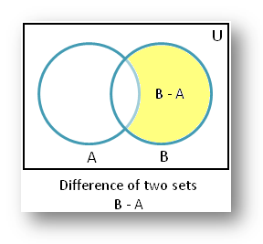

## Code:

a = {1,2,3,4,5}

b = {4,5,6,7,8}

x = b.difference(a)

print(x)

## Output:

{8,6,7}